YPL SMART DIGITAL LIBRARY
Website Architecture, Information Architecture & UX Blueprint
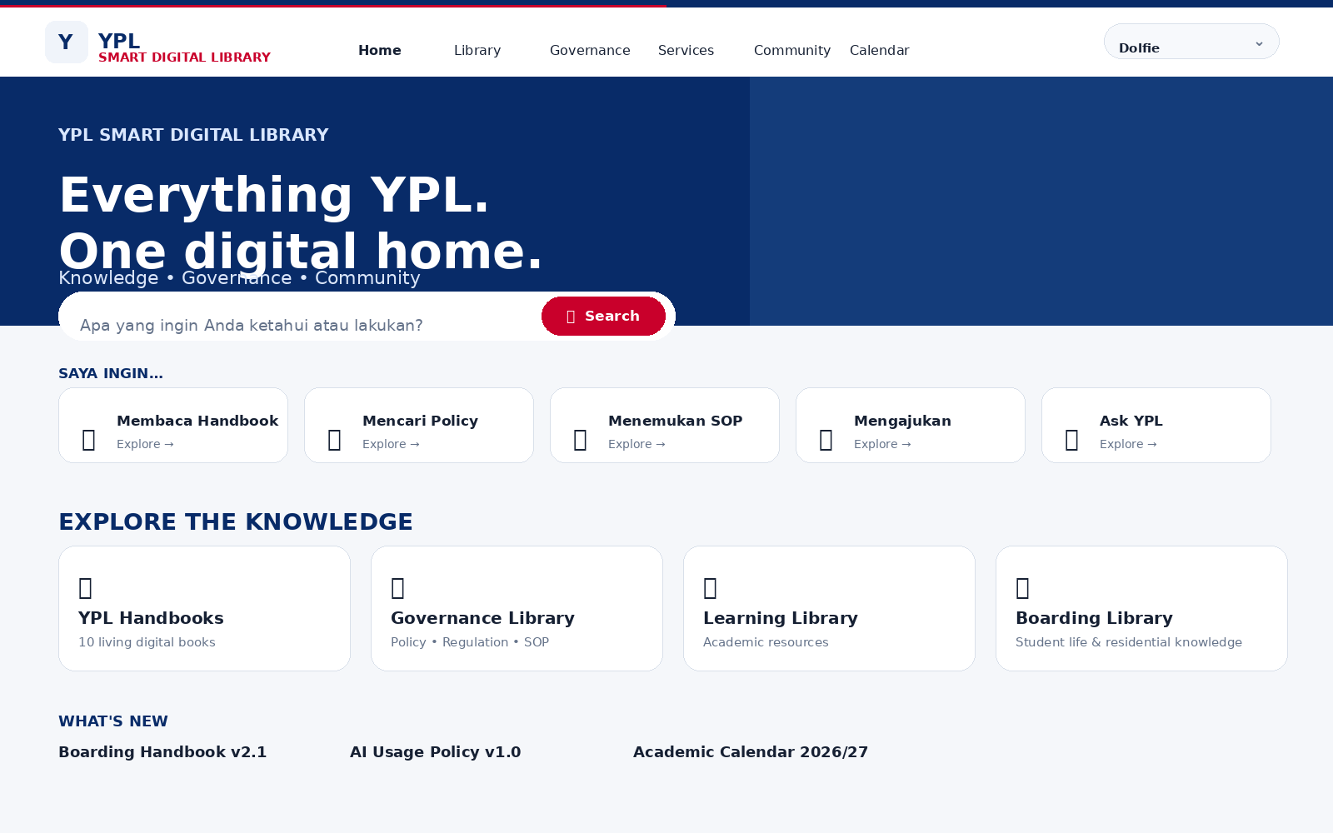
Concept direction: Premium Institutional Experience × Digital Library × Governance × Intelligent Reader

1. Ringkasan Eksekutif
YPL Smart Digital Library (YPL SDL) dirancang bukan sebagai repository PDF, melainkan sebagai Digital Knowledge, Governance and Community Platform bagi Yayasan Pendidikan Lokon. Platform ini menggabungkan pengalaman visual premium-institusional, struktur handbook yang sistematis, pencarian berbasis konteks, layanan digital, dan pengalaman membaca buku yang imersif.
Prinsip utamanya adalah: DISCOVER → KNOW → UNDERSTAND → ACT. Pengguna dapat menemukan pengetahuan, membaca dokumen dalam Reader Mode, memahami hubungan antara Handbook–Policy–SOP–Form–PIC–System, dan melakukan tindakan melalui layanan digital.

Positioning
- Nama: YPL Smart Digital Library
- Peran: Digital front door untuk knowledge, governance dan layanan YPL
- Audiens: siswa, orang tua, guru, karyawan, pimpinan, mitra dan publik
- Sumber kebenaran: dokumen resmi YPL dan sistem operasional yang terhubung
- Signature feature: Library Mode → immersive Book Reader Mode

2. Design Principles
Complexity behind simplicity — Kompleksitas taxonomy, metadata, permission dan workflow berada di belakang pengalaman UI yang sederhana.
Library, not file dump — User menemukan knowledge berdasarkan task, topic, audience dan search; bukan berdasarkan folder file.
Living digital books — 10 Handbook diperlakukan sebagai living digital books dengan versioning, chapter, navigation dan related knowledge.
Connected knowledge — Policy, SOP, Form, PIC dan System saling terhubung.
Context-aware — UI dan konten dapat diprioritaskan berdasarkan role pengguna.
Immersive reading — Saat dokumen/buku dibuka, UI bertransformasi menjadi Reader Mode yang fokus.
Futuristic through behavior — Futuristik diwujudkan melalui intelligent navigation dan interaction, bukan neon/glassmorphism berlebihan.
Accessibility first — Page flip memiliki alternatif keyboard, swipe, direct page navigation dan reduced-motion mode.

3. Target Information Architecture
- HOME
- LIBRARY → YPL Handbooks / Governance Library / Academic Library / Boarding Library / Staff Library / Parent Library / Public Collection
- GOVERNANCE → Policy / Regulation / Standard / SOP / Work Instruction / Decisions / Organization / Risk / Compliance / Quality / Document Control
- SERVICES → Forms / Applications / Workflow / My Requests / Help Center
- COMMUNITY → Directory / Units / Roles / Contacts / Community Knowledge
- CALENDAR → Foundation / Academic / Boarding / Events / Deadlines
- ASK YPL → source-grounded institutional knowledge assistant
- PUBLIC / YPL INSIGHT → Education / Programs / Facilities / Achievements / Publications / Partnerships

4. Dua Mode Utama Website

4.1 Library Mode
Mode untuk discovery: visual, editorial, bookshelf, search, filters, collections, recommendations dan audience journeys.

4.2 Reader Mode
Mode immersive untuk membaca: full-screen, two-page spread pada desktop, single-page pada mobile, page turn, table of contents, page thumbnails, search-in-book, bookmark, notes, typography controls dan Ask YPL.
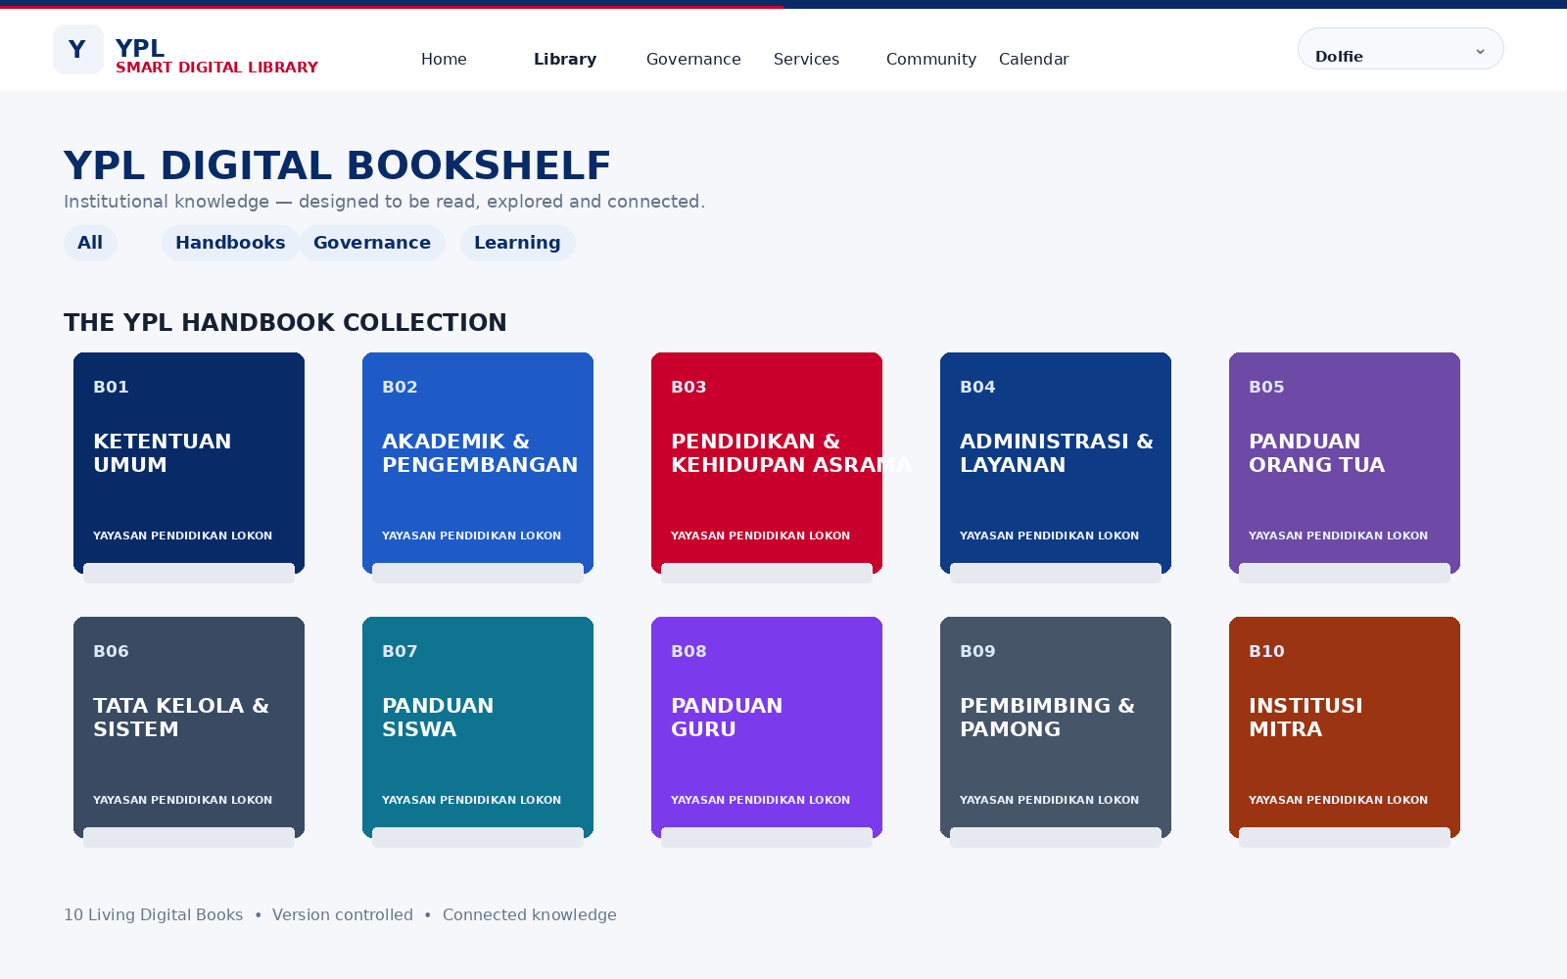
Visual 1 — Digital Bookshelf / Library Mode.
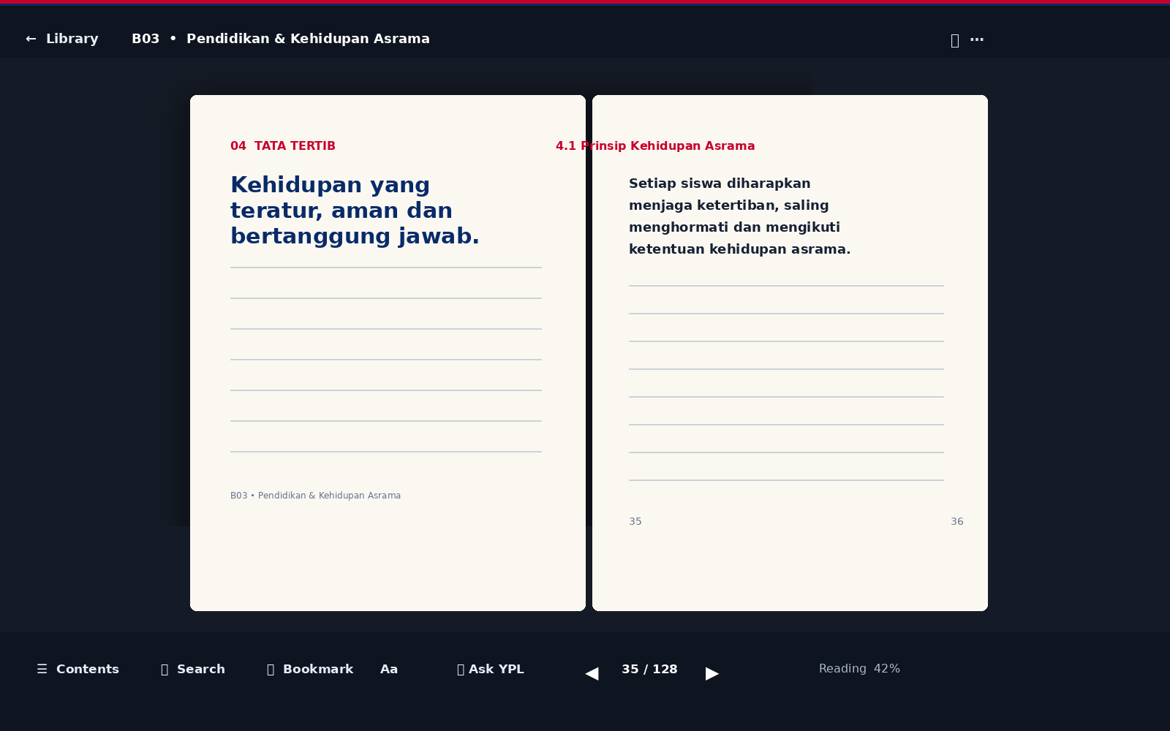
Visual 2 — Immersive Book Reader Mode.

5. Master Homepage
Homepage harus menjawab tiga pertanyaan: apa yang dapat saya cari, apa yang dapat saya lakukan, dan apa yang penting bagi saya sekarang.
- Hero: Everything YPL. One digital home.
- Universal search: Apa yang ingin Anda ketahui atau lakukan?
- Quick actions: Handbook, Policy, SOP, Formulir, Calendar, Ask YPL.
- Explore the Knowledge: Handbooks, Governance, Learning, Boarding.
- What's New: perubahan dokumen dan knowledge.
- YPL Today: deadline, event dan perubahan penting.
- Role-aware personalization setelah login.

6. Struktur 10 Handbook
Code | Handbook | Primary role
B01 | Ketentuan Umum | Foundation rules dan ketentuan umum.
B02 | Akademik & Pengembangan Potensi | Academic knowledge dan student development.
B03 | Pendidikan & Kehidupan Asrama | Boarding life, discipline, safety, permission dan development.
B04 | Administrasi, Keuangan & Layanan Siswa | Administrative and student services.
B05 | Panduan Orang Tua | Parent experience dan parent responsibilities.
B06 | Tata Kelola, Kebijakan & Sistem Manajemen YPL | Governance spine / master governance layer.
B07 | Panduan Siswa | Student experience dan expectations.
B08 | Panduan Guru | Teacher operational and academic knowledge.
B09 | Panduan Pembimbing Karakter & Pamong | Mentor/pamong operational knowledge.
B10 | Panduan Institusi Mitra | Partner and external stakeholder guidance.
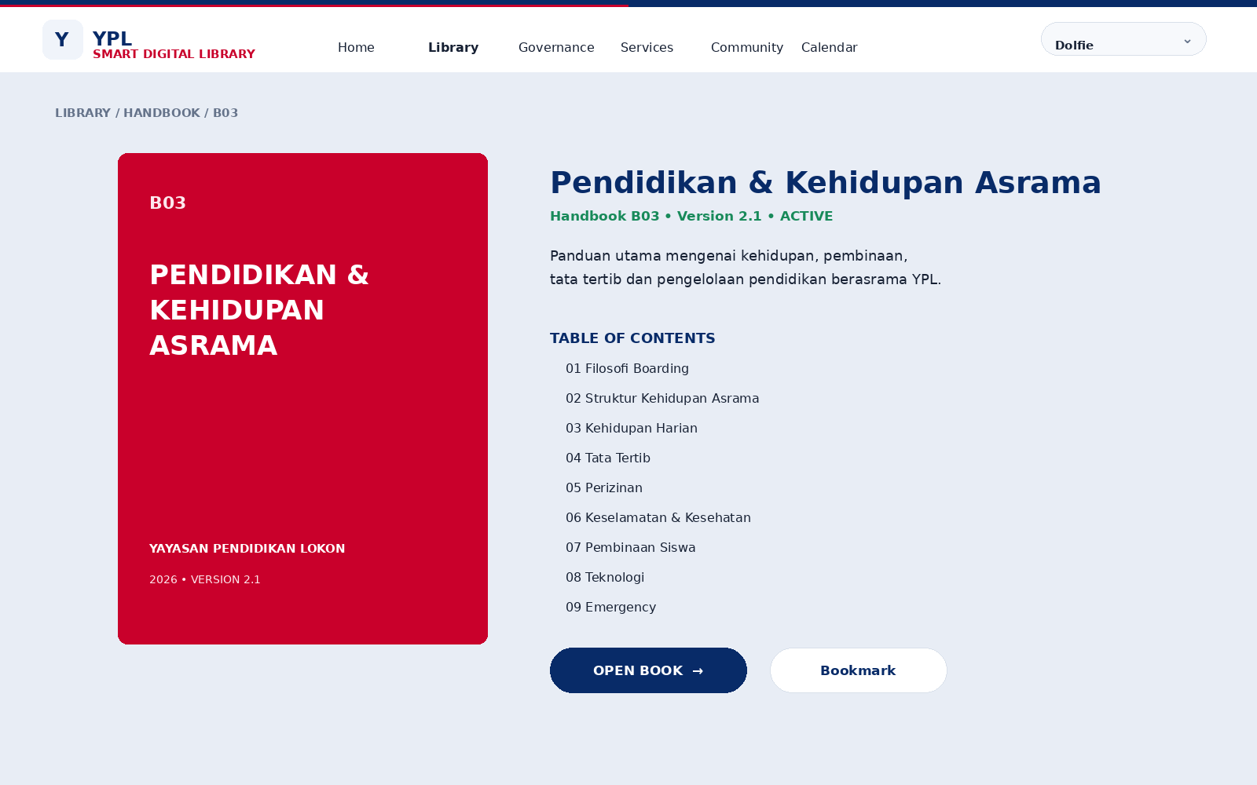

7. Document / Knowledge Model
Setiap item knowledge harus memiliki metadata dan relationship. PDF adalah artifact; metadata dan hubungan antarkonten adalah knowledge layer.
- Document ID / content ID
- Document type
- Title / subtitle
- Owner
- Approver
- Version
- Status: Draft / Under Review / Active / Expiring / Archived
- Effective date
- Review date
- Classification / visibility
- Applicable audience
- Applicable unit
- Related Handbook
- Related Policy / Regulation
- Related SOP / Work Instruction
- Related Form
- Related System
- Responsible person / PIC
- Revision history
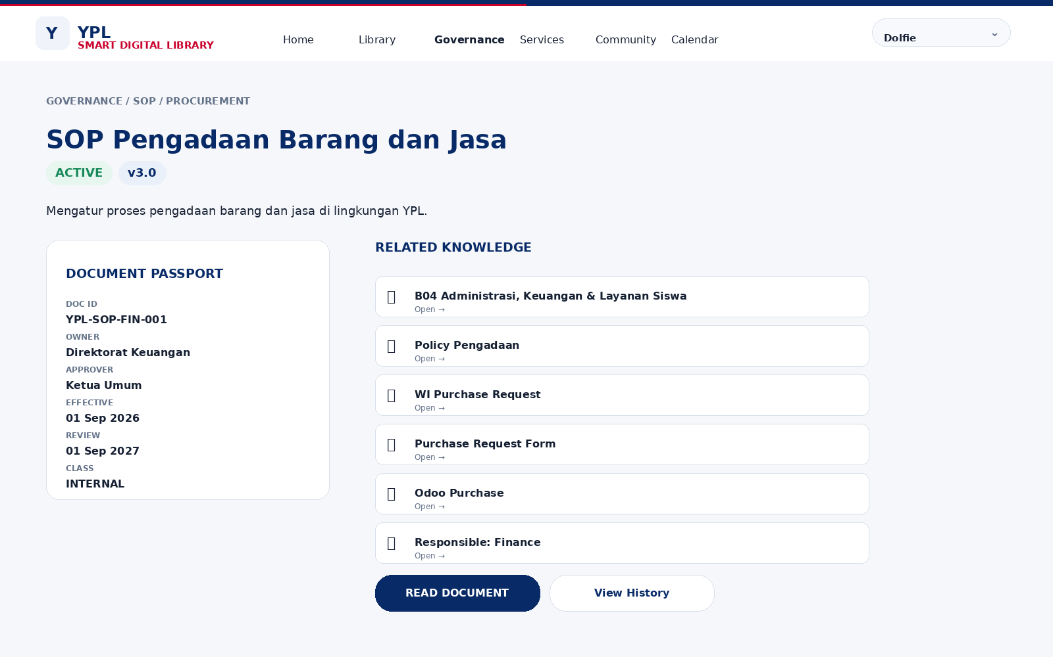

8. Reader Engine Specification
Component | Requirement
Entry transition | Cover/detail page expands into Reader Mode; library header collapses; reader takes viewport.
Desktop | Two-page spread by default; left/right page controls; optional single-page.
Tablet | Adaptive two-page or single-page depending viewport.
Mobile | Single-page portrait with swipe and explicit previous/next controls.
Page turn | Book-like page turn animation, target ~450–700 ms; reduced-motion fallback.
Navigation | TOC, page number, thumbnails, next/previous, direct page jump.
Reading tools | Search in book, bookmark, notes, font/appearance controls.
Context | Related knowledge and Ask YPL remain available without leaving the reader.
Persistence | Last page, bookmarks and notes are stored against the authenticated user.
Accessibility | Keyboard arrows, focus states, reduced motion, semantic alternative and readable contrast.
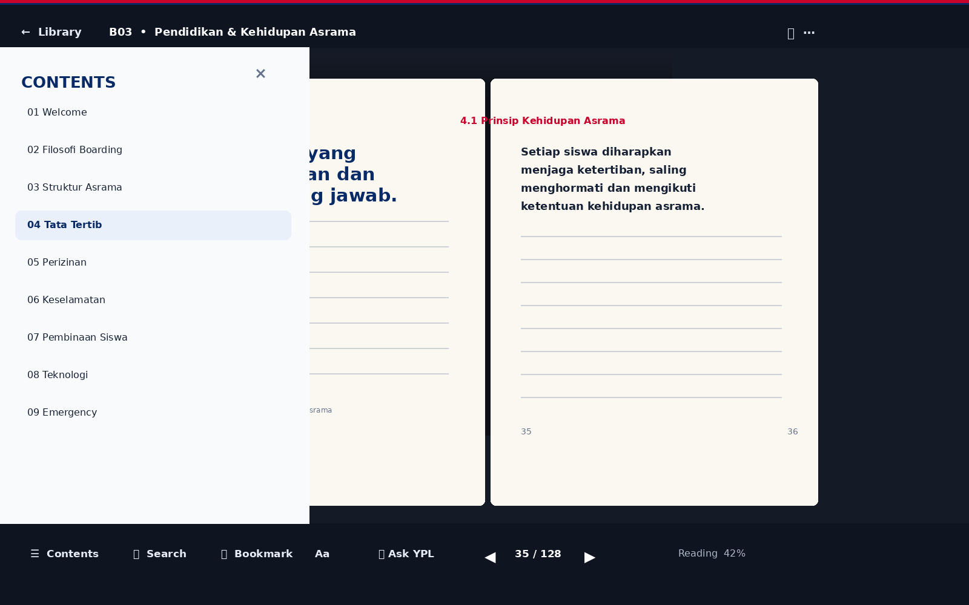
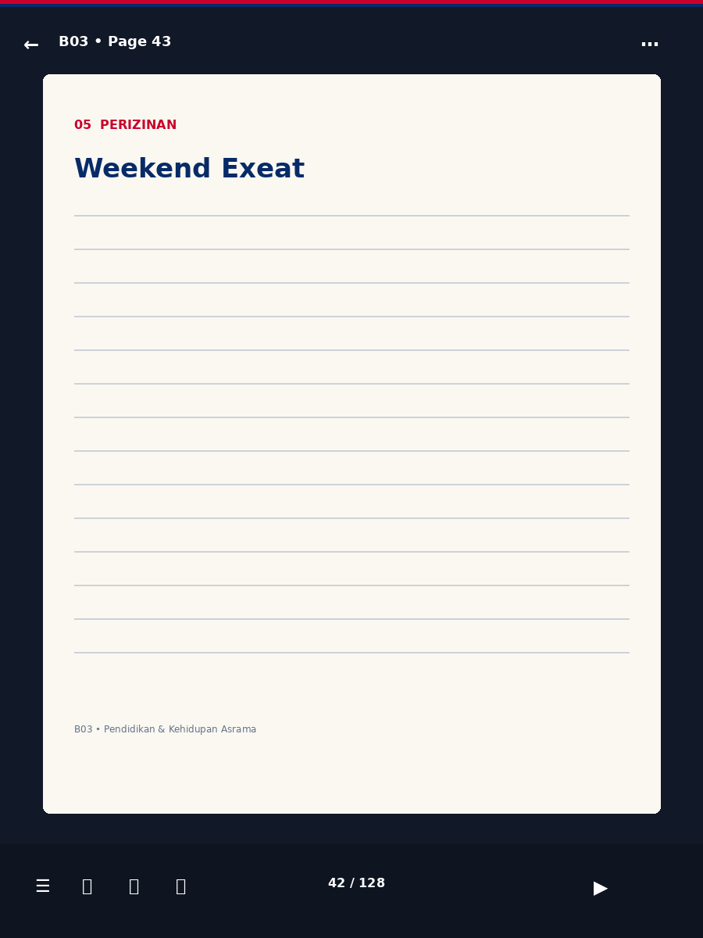

9. Universal Search
Search harus mengembalikan knowledge, bukan hanya file.
- Handbook result
- Policy / regulation result
- SOP / work instruction
- Form / service
- FAQ
- People / PIC
- Calendar / event
- AI answer with source citations
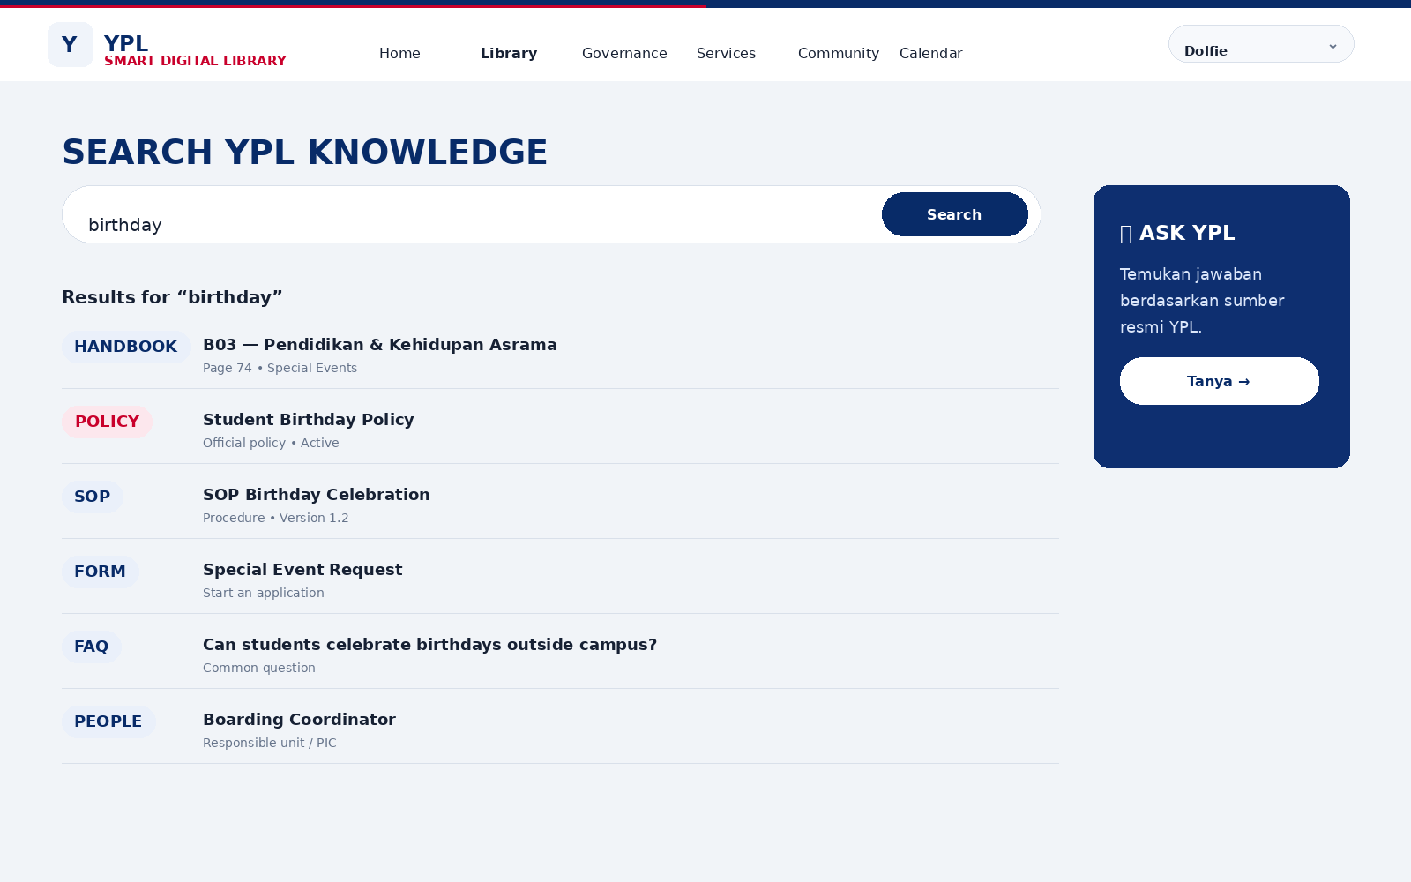

10. Services / Action Layer
Website harus mendukung pola I need to… sehingga pengguna tidak perlu memahami struktur organisasi sebelum melakukan tindakan.
- Request transportation
- Leave / HR request
- Maintenance request
- Student permission
- Purchase request
- Event request
- Incident reporting
- Document submission
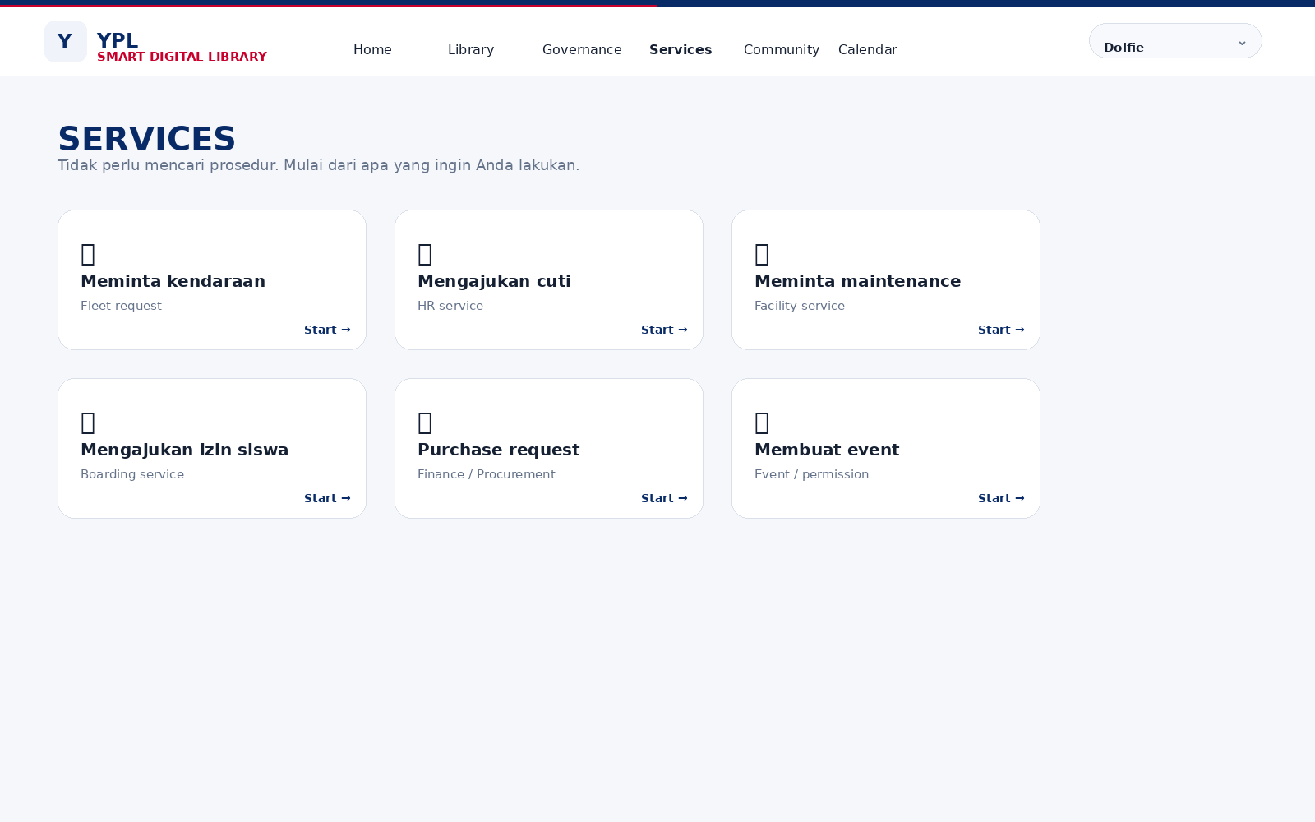

11. Role-Aware Experience
Audience | Priority experience
Siswa | Student Handbook, academic, boarding, calendar, requests, Ask YPL.
Orang Tua | Academic, boarding, finance, calendar, forms, emergency, contacts.
Guru | Academic, curriculum, assessment, policies, SOP, forms, professional development.
Karyawan | HR, services, policies, SOP, forms, requests.
Pimpinan | Governance, compliance, risk, KPI, approvals, institutional dashboard.
Mitra | Partner handbook, contacts, collaboration information, public resources.
Publik | Institutional profile, education, programs, achievements, publications.
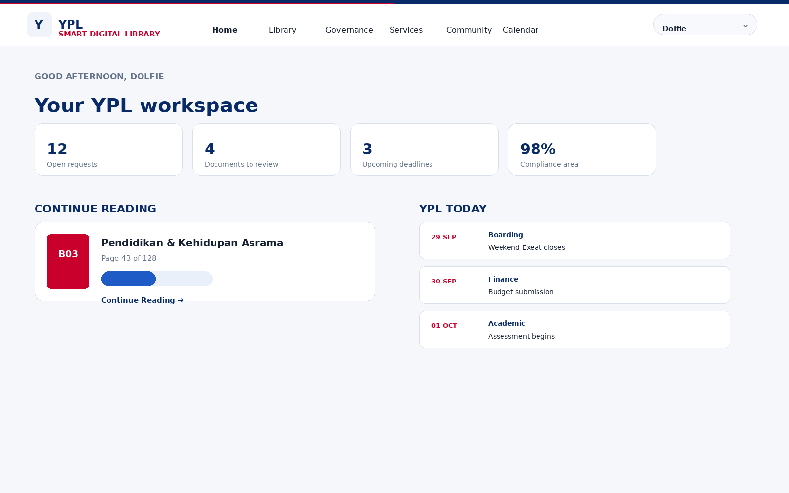

12. Knowledge Graph / Connected Knowledge
Hubungan antarkonten harus menjadi first-class object.
Contoh: Handbook → Policy → SOP → Form → PIC → System → Calendar → FAQ. User dapat melihat 'Everything related to this topic' tanpa melakukan pencarian ulang.
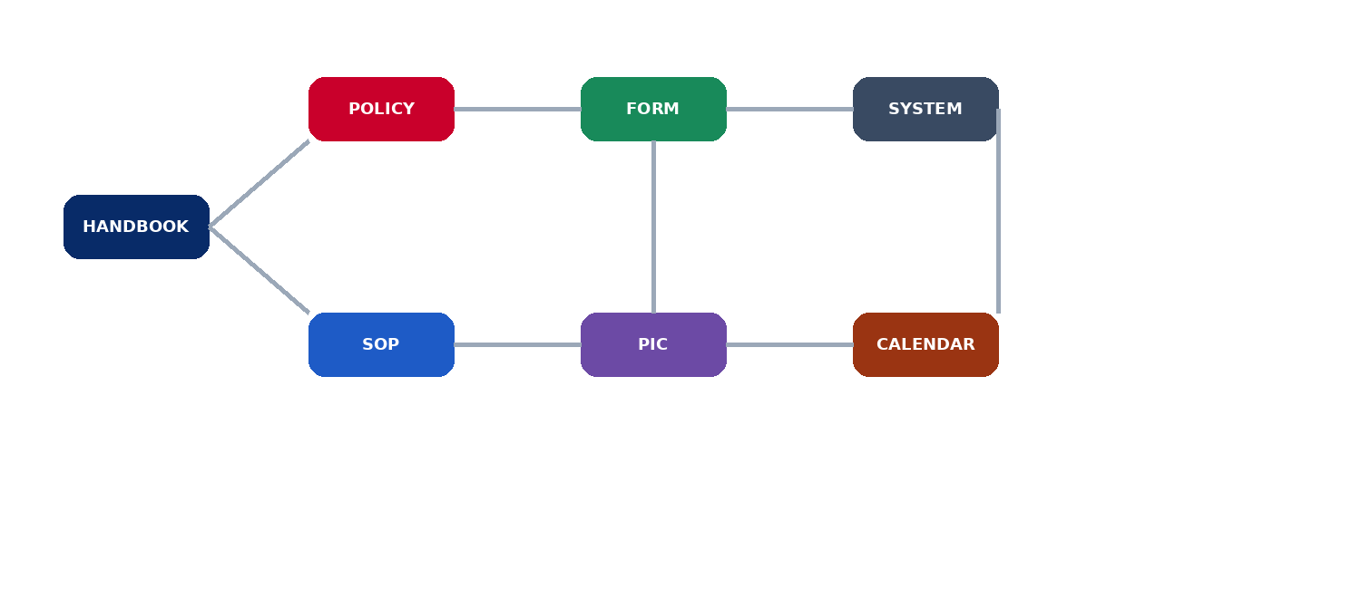

13. Governance & Document Lifecycle
YPL SDL perlu membedakan Policy, Regulation, Standard, SOP, Work Instruction, Form dan Evidence.
DRAFT → REVIEW → APPROVAL → ACTIVE → REVIEW DUE → ARCHIVED
- Version control
- Approval workflow
- Effective date
- Review date
- Audit trail
- Archive policy
- Owner and accountable approver
- Visibility / classification
- Change log / What changed?
- Impact map for related documents and systems

14. Ask YPL / AI Knowledge Layer
Ask YPL adalah institutional RAG interface. Jawaban harus grounded pada approved YPL knowledge dan selalu menunjukkan sumber. AI tidak menjadi source of truth.
- Context-aware: dapat dibatasi pada buku/chapter/dokumen yang sedang dibaca.
- Source-first: setiap jawaban memiliki citation ke dokumen dan halaman/section.
- Fallback: jika evidence tidak ditemukan, AI menyatakan bahwa sumber resmi belum ditemukan.
- Permission-aware: AI tidak boleh membocorkan konten berdasarkan role yang tidak berwenang.
- Explain document: ringkasan, siapa yang wajib mengikuti, apa yang harus dilakukan, apa yang berubah, dan related documents.

15. Visual & Interaction Direction
- Premium institutional editorial aesthetic.
- Immersive hero imagery untuk discovery, bukan dashboard padat.
- YPL navy + red sebagai institutional signature; restrained electric blue sebagai digital accent.
- Large typography, generous whitespace, modular cards, subtle motion.
- Minimal glassmorphism; hindari neon cyberpunk dan efek berlebihan.
- Blue/red top-bottom signature line dipertahankan sebagai brand motif.
- Library Mode terasa seperti premium digital library; Reader Mode terasa seperti ruang baca.
- Page flip menjadi signature interaction untuk book/handbook; standard document mode tetap cepat.
- Reader typography: sans-serif UI + serif reading body.
- Dark/Paper reading themes.

16. Technical Architecture — Conceptual
USER EXPERIENCE → LIBRARY ENGINE / READER ENGINE / SERVICE ENGINE → KNOWLEDGE & GOVERNANCE LAYER → INTEGRATION LAYER → Odoo / School / Boarding / HR / Finance / Fleet / Maintenance / ICT
YPL Smart Digital Library bukan pengganti Odoo. Ia menjadi experience, knowledge dan governance layer di atas system-of-record YPL.
- Frontend: React / Next.js atau stack setara, component-driven.
- Design system: reusable tokens, typography, color, spacing, states, accessibility.
- Content layer: structured content + document metadata + relationships.
- Reader engine: PDF/page rendering plus structured HTML reader where applicable.
- Search: full-text + metadata + relationship-aware retrieval.
- AI: retrieval-augmented generation with source citations and permission filtering.
- Integration: API layer ke Odoo dan sistem sekolah/boarding.
- Authentication: role-based access control.
- Audit: document access, changes, approvals and workflow history.

17. Sitemap Target
HOME
LIBRARY
├─ YPL Handbooks
├─ Governance Library
├─ Academic Library
├─ Boarding Library
├─ Staff Library
├─ Parent Library
└─ Public Collection
GOVERNANCE
├─ Policy
├─ Regulation
├─ Standard
├─ SOP
├─ Work Instruction
├─ Decisions
├─ Risk
├─ Compliance
└─ Document Control
SERVICES
├─ Forms
├─ Applications
├─ My Requests
└─ Help Center
COMMUNITY
├─ Directory
├─ Units
├─ Roles
└─ Contacts
CALENDAR
ASK YPL
PUBLIC / YPL INSIGHT

18. Prioritas Pengembangan
Phase | Scope
Phase 1 — Foundation | Information architecture, design system, authentication, taxonomy, document metadata, Library Mode.
Phase 2 — Living Books | 10 Handbook digital bookshelf, book detail, Reader Mode, page navigation, page flip, TOC, bookmarks.
Phase 3 — Governance | Policy/SOP/Document Passport, lifecycle, versioning, review, approval, connected knowledge.
Phase 4 — Services | Forms, workflow, My Requests, contextual task journeys, integrations.
Phase 5 — Intelligence | Universal search, Ask YPL, source-grounded AI, recommendations, knowledge graph.
Phase 6 — Ecosystem | Odoo and other YPL systems, role dashboards, analytics, public knowledge layer.

19. Visualisation Prompt Plan
Karena visual high-fidelity dan arsitektur tekstual sebaiknya tidak dipaksakan dalam satu prompt, pembuatan visual dapat dilakukan bertahap. Urutan prompt yang direkomendasikan:
- Prompt 1 — Design System & Creative Direction: buat visual identity, color tokens, typography, spacing, buttons, cards, icons, navigation dan motion principles.
- Prompt 2 — Homepage High-Fidelity: buat screen desktop 1600×1000 untuk Library Mode dengan hero, universal search, I need to, knowledge collections, what's new dan YPL Today.
- Prompt 3 — Digital Bookshelf: buat screen koleksi 10 Handbook dengan cover yang premium, hover interaction dan metadata.
- Prompt 4 — Book Detail: buat screen cover, synopsis, version/status, TOC, metadata dan Open Book.
- Prompt 5 — Reader Mode: buat high-fidelity two-page spread dengan page turn affordance, toolbar, page counter dan reading progress.
- Prompt 6 — Reader Interaction States: buat variasi Reader dengan TOC overlay, thumbnails, search-in-book, bookmark, notes dan Ask YPL.
- Prompt 7 — Governance Detail: buat Document Passport, Policy/SOP detail, related knowledge, version history dan compliance status.
- Prompt 8 — Services: buat task-oriented service portal dengan I need to dan workflow.
- Prompt 9 — Role Dashboards: buat dashboard Siswa, Orang Tua, Guru, Karyawan dan Pimpinan.
- Prompt 10 — Mobile: buat responsive Library dan Reader Mode untuk smartphone.
- Prompt 11 — Prototype Flow: visualisasikan transition Home → Book Detail → Cover Open → Reader → Next Page → TOC → Search → Related Knowledge → Back to Library.
- Prompt 12 — Final Design System Audit: satukan seluruh screen menjadi satu design system dan cek konsistensi.

20. Acceptance Criteria Utama
- User dapat menemukan knowledge tanpa mengetahui nama file.
- 10 Handbook tampil sebagai digital books, bukan sekadar PDF cards.
- Klik buku/dokumen dapat masuk ke Reader Mode tanpa kehilangan konteks.
- Reader desktop mendukung two-page spread dan page-turn interaction.
- Reader mobile menggunakan single-page adaptive layout.
- User dapat TOC, direct page jump, search-in-book dan bookmark.
- Setiap official document memiliki status, version, owner, approver, effective/review date.
- Policy, SOP, Form, PIC dan System dapat saling terhubung.
- Search mengembalikan dokumen dan action/service.
- Ask YPL memberikan jawaban berbasis sumber resmi dan citation.
- Role mengubah prioritas konten tanpa membuat arsitektur website menjadi terpisah-pisah.
- Public content dapat dipublikasikan tanpa membuka internal governance content.

21. Penutup — Target Experience
YPL Smart Digital Library harus membuat pengguna merasa bahwa YPL memiliki satu perpustakaan digital yang hidup: mudah ditemukan, nyaman dibaca, terhubung dengan governance, dapat ditindaklanjuti, dan semakin cerdas seiring bertambahnya institutional knowledge.
DISCOVER → KNOW → UNDERSTAND → ACT

